Final Project Proposal Report
Low-Power Real-Time Colonoscopy Polyp Detection on STM32MP257 NPU
A Clinically Motivated Edge-AI Computer-Aided Detection Prototype Using Lightweight YOLO
Prepared for: Biomedical AI / Embedded AI Final Project Evaluation
Prepared by: Project Team
Date: May 2026

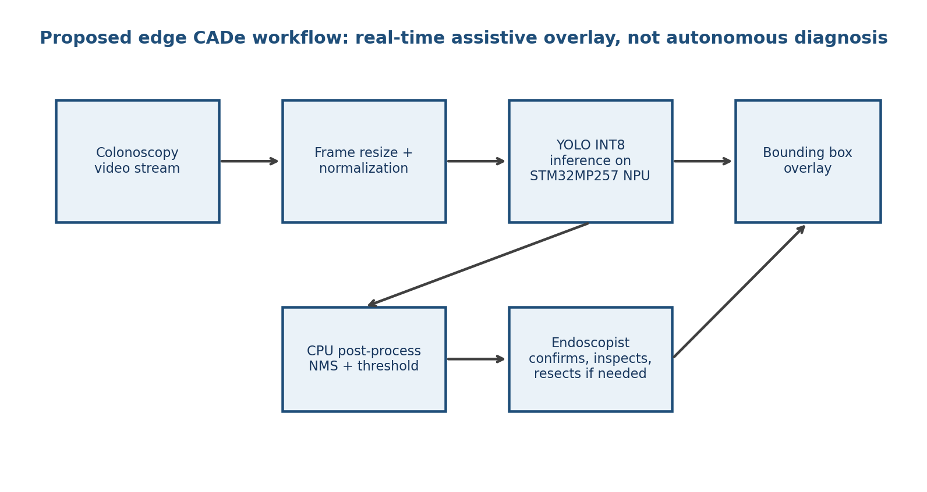
Figure 1. Proposed workflow: an assistive real-time overlay for endoscopists, not an autonomous diagnostic device.

Executive Summary
We propose a master-level final project that builds and evaluates a low-power, real-time computer-aided detection (CADe) prototype for colonoscopy polyp detection on the STM32MP257 neural processing unit (NPU). The system will train a lightweight YOLO detector using publicly available colonoscopy polyp datasets, quantize the model to INT8, deploy it through the STM32MP25 edge-AI toolchain, and measure both clinical task performance and embedded-system performance.
Clinical motivation. Colorectal cancer is a major global disease burden. WHO identifies colorectal cancer as the third most common cancer worldwide and the second leading cause of cancer-related death [1]. Screening colonoscopy is clinically important because precancerous polyps can be detected and removed before becoming cancer [2]. The project therefore targets a direct clinical workflow: during colonoscopy, highlight suspicious polyp regions in real time so the endoscopist can inspect, confirm, and remove lesions if appropriate.
Why this is not merely a toy AI project. Real-time AI-assisted polyp detection is already clinically meaningful: commercial CADe systems such as GI Genius, Fujifilm CAD EYE, Olympus ENDO-AID, and Olympus/Odin CADDIE exist and are intended to assist clinicians during live colonoscopy [3-6]. This validates the clinical need. Our project does not claim to replace those medical devices; instead, it studies whether a similar CADe concept can be implemented as a low-cost, low-power edge-AI prototype using STM32MP257.
Engineering contribution. The novelty for a course final project is the end-to-end deployment study: lightweight YOLO, INT8 quantization, NPU conversion, real-time latency/FPS benchmarking, and external-dataset validation. This is a realistic, measurable, and clinically interpretable project.
Recommended project framing: 'Edge-assisted real-time polyp detection for colonoscopy triage and intra-procedure visual support.' The system is an assistive research prototype, not an independent diagnostic device.

1. Clinical Rationale and Direct Clinical Relevance
Colonoscopy is unique among cancer screening procedures because it allows both detection and immediate removal of premalignant lesions. CDC explains that colorectal screening can find precancerous polyps so they can be removed before turning into cancer [2]. Therefore, a polyp detector has a direct clinical action pathway: detect a suspicious region, draw the endoscopist's attention, allow closer inspection, and support timely removal or biopsy when clinically indicated.
The problem is not that colonoscopy lacks experts; the problem is that detection is visually demanding and operator dependent. Clinical trials and reviews describe real-time CADe as a tool to improve adenoma or polyp detection. A 2025 PRISMA-aligned meta-analysis of randomized trials reported that GI Genius-assisted colonoscopy increased adenoma detection rate compared with standard colonoscopy (RR 1.12, 95% CI 1.03-1.22) and improved several secondary detection outcomes [7]. The COLO-DETECT trial introduction notes that missed polyps are clinically important and that polyp detection quality is linked to post-colonoscopy colorectal cancer risk [8].
Clinical issue | Why it matters | How this project addresses it
Missed or subtle polyps | Small, flat, or visually subtle lesions may be overlooked during live video review. | YOLO highlights candidate regions in real time to guide attention.
Variation in detection quality | Adenoma/polyp detection is operator dependent and affected by fatigue, visibility, and experience. | The edge AI assistant provides a consistent second-observer signal.
Access and cost gap | Commercial CADe systems exist but are high-end, closed, and not universally available. | STM32MP257 offers a low-power embedded deployment path for feasibility study.
Need for measurable clinical endpoint | A project should connect AI output to a clinically meaningful task. | Evaluation reports polyp recall, false positives, mAP, and external-dataset generalization.

2. Existing Systems and the Project Gap
This area is active and clinically validated; that is a strength, not a weakness. Commercial CADe products demonstrate that real-time polyp detection is a recognized clinical use case. Medtronic's GI Genius is described as a real-time computer-assisted tool for detecting colonic mucosal lesions during standard white-light endoscopy [3]. Fujifilm received FDA 510(k) clearance for CAD EYE for real-time detection of colonic mucosal lesions such as polyps and adenomas [4]. Olympus ENDO-AID and CADDIE similarly target real-time colonoscopy lesion detection [5,6].
System / evidence | Clinical implication | Why the proposed project is still worthwhile
GI Genius, CAD EYE, ENDO-AID, CADDIE | CADe is already considered a credible clinical workflow. | The project studies a low-power, open research prototype rather than a commercial tower-based system.
Randomized trials / meta-analyses | Real-time CADe can improve detection metrics in colonoscopy. | The project evaluates whether such a workflow can be approximated on embedded NPU hardware.
STM32MP257 NPU | 1.35 TOPS edge AI capability allows embedded inference without a desktop GPU. | The project contributes quantitative deployment data: FPS, latency, quantization loss, and model-size tradeoffs.
Gap statement. The project is not trying to invent polyp CADe from scratch. The research question is: can a compact YOLO model, trained on public colonoscopy datasets and quantized for STM32MP257, achieve useful real-time performance while retaining acceptable polyp detection accuracy?

3. Public Data Availability
The project is feasible because suitable colonoscopy polyp datasets are publicly available for research and education. Kvasir-SEG provides 1,000 polyp images with expert-annotated segmentation masks and bounding-box information [9]. CVC-ClinicDB provides 612 colonoscopy frames with corresponding polyp masks and is restricted to research and educational use [10]. These annotations can be converted into YOLO bounding boxes by extracting the minimal rectangle surrounding each binary mask.
Dataset | Size and annotation | Role in project | Access / limitation
Kvasir-SEG | 1,000 polyp images with segmentation masks; bounding-box information is available. | Primary training/validation dataset for YOLO detector. | Public research dataset from Simula; also mirrored on Kaggle.
CVC-ClinicDB | 612 colonoscopy frames with pixel-level polyp masks. | External validation dataset to test generalization. | Research/educational use; commercial use prohibited by dataset terms.
Optional: ETIS-LaribPolypDB / CVC-ColonDB | Smaller external benchmarks. | Robustness testing if time permits. | Public mirrors exist; use only with proper citation and license review.

4. Proposed Technical Approach
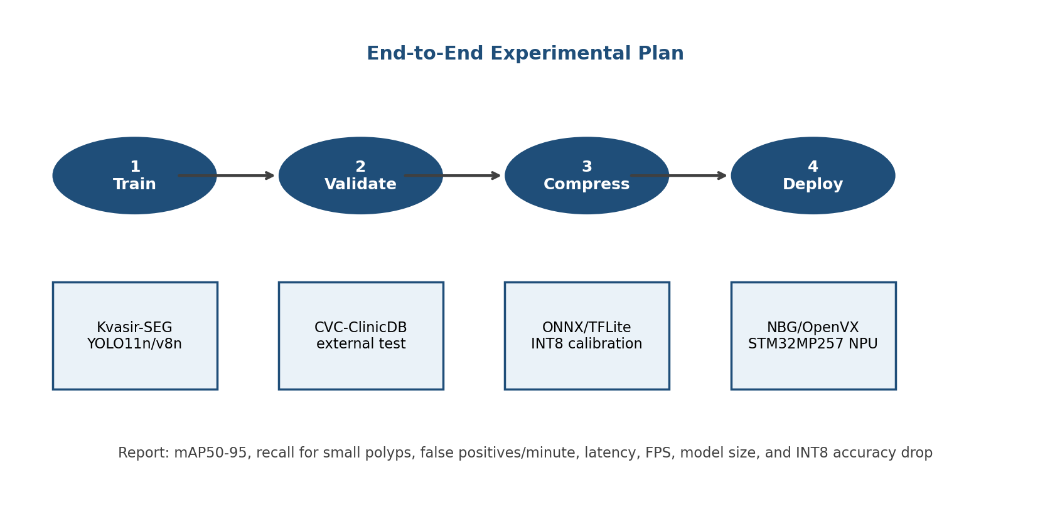
Figure 2. End-to-end experiment plan from public datasets to embedded NPU deployment.
Model selection. We will start with YOLOv26n, YOLO11n, and YOLOv8n detection models because they are small enough for embedded deployment while remaining strong baselines. Larger YOLO variants will be used only as offline reference models if time allows.
- Convert segmentation masks into YOLO bounding boxes and build patient/video-aware train/validation splits where metadata permits.
- Train lightweight YOLO models on Kvasir-SEG, using image augmentation suitable for endoscopy such as brightness/contrast changes, blur, and scale jitter.
- Evaluate on held-out Kvasir-SEG and external CVC-ClinicDB to measure generalization rather than only random-split performance.
- Export to ONNX/TFLite, perform INT8 quantization, and convert to the STM32MP25 NPU-compatible deployment format when supported by ST Edge AI tools.
- Measure latency, FPS, model size, CPU utilization, and accuracy drop after quantization on STM32MP257.

5. Hardware Feasibility and Real-Time Budget
The STM32MP257 is a reasonable edge target for this project. ST lists STM32MP257D-class devices with dual Cortex-A35 cores up to 1.5 GHz and an NPU up to 1.35 TOPS [11]. The key engineering constraint is not the peak TOPS alone; real performance depends on quantization, memory bandwidth, operator support, pre/post-processing, and the cost of non-maximum suppression.
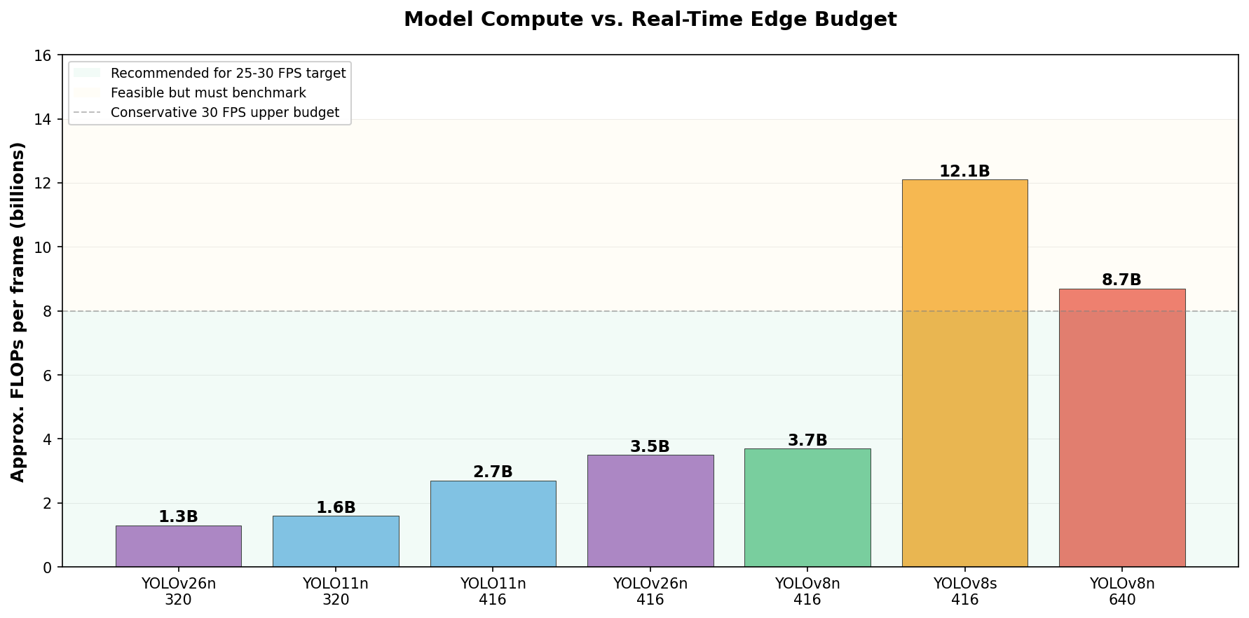
Figure 3. Approximate model compute at smaller input sizes. FLOPs are scaled from published 640x640 YOLO model tables; actual latency must be measured on the board.
Practical target. For a course project, the primary real-time target should be at least 15 FPS end-to-end, with a stretch goal of 25-30 FPS. Based on published YOLO model compute, YOLOv26n , YOLO11n, or YOLOv8n at 320-416 input resolution is the most realistic choice, with YOLOv26n showing the best accuracy-latency tradeoff. YOLOv8s at 416 may be evaluated as a higher-accuracy but higher-latency option.
Candidate | Approx. compute | Expected deployment fit | Use in project
YOLO11n @ 320 | ~1.6B FLOPs/frame | Very likely feasible | Fastest baseline and deployment fallback.
YOLO11n @ 416 | ~2.7B FLOPs/frame | Strong fit | Primary deployment candidate.
YOLOv8n @ 416 | ~3.7B FLOPs/frame | Strong fit | Primary or secondary deployment candidate.
YOLOv26n @ 416 | ~3.5B FLOPs/frame | Strong fit | Best accuracy-latency tradeoff; recommended primary model.
YOLOv8s @ 416 | ~12.1B FLOPs/frame | Possible but tighter | Accuracy/latency tradeoff experiment.
YOLOv8s @ 640 | ~28.6B FLOPs/frame | Not recommended | Offline reference only.
Definition of real time. Commercial endoscopy video is usually perceived as real-time at approximately video frame rate, but an assistive academic prototype can be credible at 15 FPS if latency is stable and the overlay does not disrupt the clinical workflow. The report will therefore distinguish model-only latency from end-to-end latency including preprocessing and post-processing.

6. Evaluation Plan
Category | Metric | Why it is needed
Detection accuracy | mAP50, mAP50-95 | Standard object-detection performance.
Clinical sensitivity | Per-image recall / per-polyp recall | Missing a polyp is clinically more concerning than an extra candidate box.
Usability | False positives per image or per minute | Too many prompts can distract endoscopists.
Generalization | Train Kvasir-SEG, test CVC-ClinicDB | Tests whether the model survives domain shift.
Embedded feasibility | Latency, FPS, model size, memory usage | Shows whether the system can run on STM32MP257.
Compression effect | FP32 vs INT8 accuracy drop | Quantifies the cost of NPU-ready quantization.
Success criteria. A successful final project does not require regulatory-grade performance. It should demonstrate: (1) a working detector on public data, (2) external validation, (3) successful INT8/NPU deployment or a clearly documented fallback path, and (4) quantitative evidence that latency is close to real time.

7. Why This Topic Is Stronger Than BCCD Blood Cell Detection
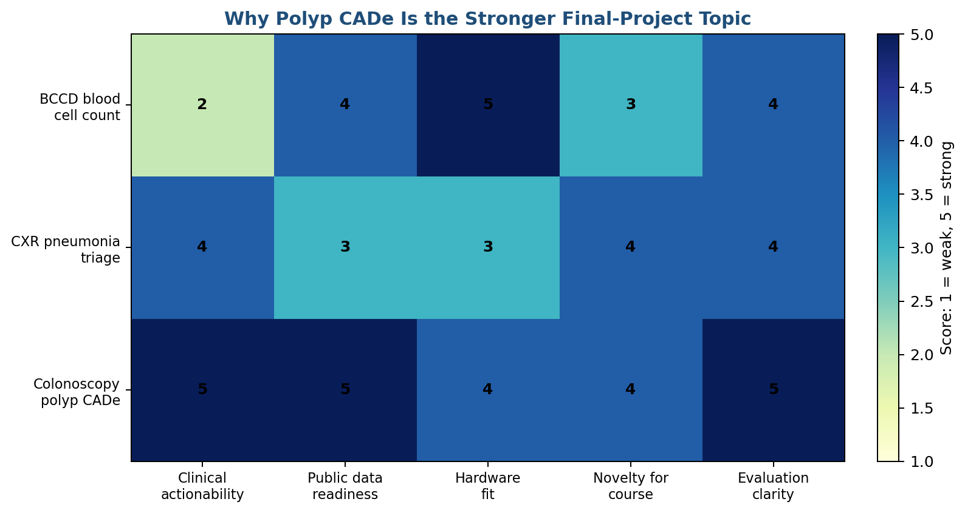
Figure 4. Qualitative project selection matrix. Polyp CADe scores higher because the clinical action is direct and measurable.
Blood-cell detection on BCCD is useful for teaching object detection and embedded deployment, but its clinical action is indirect. Detecting RBC/WBC/platelets in a small public smear dataset does not directly produce a clinical decision comparable to a complete blood count or manual differential. In contrast, polyp detection directly supports a recognized colonoscopy action: inspect and remove suspicious lesions. This makes the colonoscopy project more persuasive for a biomedical AI course emphasizing clinical relevance.

8. Risks and Mitigation
Risk | Impact | Mitigation
NPU conversion fails because of unsupported operators | Could block deployment | Export simplified YOLO head, use fixed input size, avoid unsupported post-processing in graph, run NMS on CPU.
INT8 quantization reduces sensitivity | Could harm clinical usefulness | Use representative calibration images; compare FP32/INT8; tune confidence threshold for high recall.
Dataset is image-based, not full video | May weaken real-time claim | Run pseudo-video inference on frame sequences and report frame-level latency; clearly state this is a prototype.
False positives distract users | Clinical usability concern | Report false positives per image/minute and tune threshold; prioritize recall but discuss alert fatigue.
External validation performance drops | Generalization concern | Use it as a core scientific result; analyze failure cases by size, blur, lighting, and domain shift.

9. Proposed 6-Week Schedule
Week | Deliverable
1 | Download datasets, verify licenses, convert masks to YOLO bbox labels, create baseline visualizations.
2 | Train YOLO11n/YOLOv8n/YOLOv26n on Kvasir-SEG; define validation protocol.
3 | External validation on CVC-ClinicDB; perform error analysis and threshold tuning.
4 | Export ONNX/TFLite, perform INT8 quantization, validate accuracy after quantization.
5 | Deploy to STM32MP257 NPU or benchmark fallback runtime; collect latency/FPS/model-size data.
6 | Prepare demo video, final report, slides, and reproducibility package.

10. Expected Contributions
- A clinically motivated CADe prototype for colonoscopy polyp detection using public datasets.
- A reproducible conversion pipeline from segmentation masks to YOLO bounding boxes.
- An embedded deployment study on STM32MP257 NPU with INT8 quantization.
- A quantitative accuracy-latency tradeoff analysis for lightweight YOLO models.
- A clear discussion of limitations: research prototype, not diagnostic software; no patient-level clinical trial; no regulatory claim.

Conclusion
This project is clinically convincing because the AI output maps to an immediate clinical action during colonoscopy: drawing attention to a suspected polyp for closer inspection and possible removal. It is feasible because public annotated datasets exist, lightweight YOLO models are small enough for embedded inference, and STM32MP257 provides an NPU suitable for low-power AI experimentation. It is academically appropriate because it combines biomedical AI, model compression, external validation, and embedded deployment in a single measurable project. The team should present it as an assistive edge-AI CADe prototype, not as a replacement for endoscopists or commercial regulated systems.

References
[1] World Health Organization. Colorectal cancer fact sheet. https://www.who.int/news-room/fact-sheets/detail/colorectal-cancer
[2] CDC. Screening for Colorectal Cancer. https://www.cdc.gov/colorectal-cancer/screening/
[3] Medtronic. GI Genius intelligent endoscopy module. https://www.medtronic.com/en-us/healthcare-professionals/products/digestive-gastrointestinal/gastrointestinal-artificial-intelligence/gi-genius-intelligent-endoscopy-module.html
[4] Fujifilm. FDA 510(k) clearance for CAD EYE colonic polyp detection. https://www.fujifilm.com/us/en/news/healthcare/fujifilm-receives-clearance-for-cad-eye
[5] Olympus. ENDO-AID CADe real-time computer-aided detection platform. https://www.olympus-europa.com/company/en/news/press-releases/2020-10-09t08-30-00/olympus-launches-endo-aid-an-ai-powered-platform-for-its-endoscopy-system.html
[6] Olympus / Odin Medical. CADDIE cloud-based AI endoscopy FDA clearance. https://www.olympusamerica.com/press-release/2024-09-05/first-cloud-based-ai-endoscopy-system-colonoscopy-receives-fda-clearance
[7] Sattar et al. Effectiveness of the GI Genius Computer-Aided Detection System Versus Standard Colonoscopy: Systematic Review and Meta-Analysis of RCTs. PubMed PMID: 41246784. https://pubmed.ncbi.nlm.nih.gov/41246784/
[8] Seager et al. COLO-DETECT trial, Lancet Gastroenterology & Hepatology, 2024. PubMed PMID: 39153491. https://pubmed.ncbi.nlm.nih.gov/39153491/
[9] Kvasir-SEG dataset. Simula. https://datasets.simula.no/kvasir-seg/
[10] CVC-ClinicDB dataset. https://polyp.grand-challenge.org/CVCClinicDB/ and Kaggle mirror https://www.kaggle.com/datasets/balraj98/cvcclinicdb
[11] STMicroelectronics. STM32MP257D product page and NPU specifications. https://www.st.com/en/microcontrollers-microprocessors/stm32mp257d.html
[12] Ultralytics YOLOv8 model table. https://huggingface.co/Ultralytics/YOLOv8
[13] Ultralytics YOLO11 model table. https://huggingface.co/Ultralytics/YOLO11
[14] Ultralytics YOLOv26 model information. https://docs.ultralytics.com/models

